

**September 1st: Membership Due**

OCT

**Founders Day**

Save The Date

*Location TBD*

**Holiday Pot-luck & Growing Roses From Seed**

lead by Dave Cannistraro

*Westwood Public Library*

**20**

JAN

**Installation Ceremony & Winterizing Your Roses**

lead by Jeanette Danehy

*Waltham Library*

NOV

**Rose-Field Trip**

Maine Coastal Botanical Garden

MAY

**18**

**Prepping the Queens & Other Rose Show Tips**

lead by Jeannette Danehy

*Westwood Public Library*

**Rose Gardens of Italy**

lead by Valentina Nardini

*Orchard Cove, Canton MA*

**17**

FEB

**Organic Gardening & Rose Sale Pick-Up**

lead by Paul Raymond

*Pompositticut Community Center*

APR

**27**

**New England Rose Society Rose Show**

New England Botanical Center at Tower Hill

**Workshop: Arrangements**

lead by Misty Florez

*Waltham Library*

MAR

**16**

**ARS National Rose Show**

Crown Plaza

*Warwick, RI*

SEPT

**9-13**

**Founders Day**

Ben Hamilton Anderson

*Evviva Trattoria*

OCT

JUL

**20**

JUN

**15**

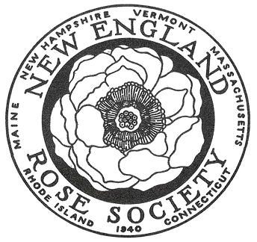

‘23-’24

Event Calendar

**18**

**Preparation for National ARS Convention**

lead by TBD

*Orchard Cove, Canton MA*

AUG

**16**

**29**

**19**