CONNECTICUT BUS TOUR
ELIZABETH PARK AND CONNETICUT ROSE SOCIETY ROSE SHOW
SUNDAY, JUNE 24, 2012
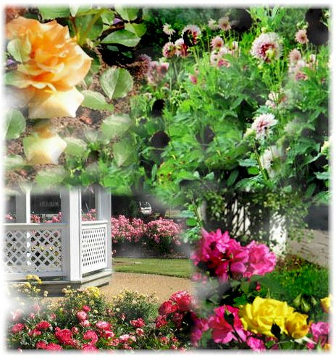

Join us on a tour to one of Connecticut’s finest horticultural destinations. Spend the morning touring Historic Elizabeth Park the oldest Municipal Rose Garden in the country featuring its world famous Rose Garden that showcases 15,000 plants with over 800 varieties of roses. Enjoy a leisurely morning strolling through the Garden taking in the fragrance of all varieties blooming in their peak time. Wind your way through the rambling rose covered arched walkways, each lined with beds of roses in every shape and color you could imagine. Continue on through the Tree Trail enjoying more than forty labeled specimens from very common to very unusual. Be sure to check out the 100 year old Greenhouse structures where annuals and other plants are grown and save time to check out some of the many other gardens that may interest you including the Herb Garden, Perennial Garden, Rock Garden and Heritage Garden. Be sure to bring your lunch to enjoy in the picnic area where color and fragrance is all around.

After lunch you will enjoy entrance to the Connecticut Rose Society’s June Rose Show. This spectacular showcase on display at Elizabeth Park is hosted by the Connecticut Rose Society and features a vast array of roses. This is a great opportunity to mingle and learn from many local Rosarians. Rose bushes and rose calendars will also be on sale at the event. So don’t miss out book now, space is limited.
Date: Sunday, June 24, 2012
Price: $49.00 per person
Time: Departs Stop 1 at 6:30am – Returns to Stop 1 approx. 5:00pm (*see schedule attached)
Excursion Price Includes:
- Round Trip Private Ground Transportation from your choice of *2 Designated Pick-Up Points
- All Taxes, Tolls, Bus Parking and Tips
- Morning Snack Pack

Entrance to Elizabeth Park
- Entrance to Connecticut Rose Society Rose Show
- Itinerary/Information

Note:
- Tour is scheduled rain or shine so dress for inclement weather.
- Dress for comfort, you will be doing a lot of walking
- Once payment is received, no refunds will be issued for any reason unless the tour is cancelled.

No Food or Beverages are included in this tour (except morning snack pack).

It is recommended bring your own bag lunch as there are no food facilities at the Park.

Depart 6:30am Pelham Street Park and Ride – Methuen, MA I-93 - Exit 47
Depart 7:15am Park and Ride – Berlin, MA I-495 – Exit 26
Arrive 8:45am Elizabeth Park, Hartford, CT
Free time to tour Gardens, Shop and Lunch
(Bring your own bag lunch to enjoy in the beautiful picnic area)
12:00pm Entrance to Connecticut Rose Society Show, Rose Sale
3:00pm Depart Elizabeth Park to head home
Est. 4:30pm Park and Ride – Berlin, MA I-495 – Exit 26
Est. 5:00pm Arrive Pelham Street Park and Ride, I-93 - Exit 47

For questions or more information contact Teresa Mosher purplerosesinbloom@yahoo.com
METHUEN GARDEN CLUB AND NEW ENGLAND ROSE SOCIETY MEMBER

CONNECTICUT ONE DAY BUS EXCURSION CONTRACT
ELIZABETH PARK AND CONNETICUT ROSE SOCIETY ROSE SHOW
SUNDAY, JUNE 24, 2012
$49.00 per person

Excursion Price Includes:
- Round Trip Private Ground Transportation from your choice of *2 Designated Pick-Up Points
- All Taxes, Tolls, Bus Parking and Tips
- Morning Snack Pack

Entrance to Elizabeth Park
- Entrance to Connecticut Rose Society Rose Show
- Itinerary/Information
Please Note the Following Information:
- Tour is scheduled rain or shine so dress for inclement weather.
- This tour entails a lot of walking so wear comfortable shoes and be prepared to walk.

Once payment is received there will be no refunds for cancellations for any reason. No refunds for no shows or for any unused portion of the tour. Tour is subject to a minimum number of people. By June 1, 2012 if minimum is not reached and organizer cancels tour, money will be refunded in full.

No Food or Beverages are included in this tour (except morning snack pack).

It is recommended that you bring a bag lunch.
- It is the responsibility of the passenger to be at designated departure points on time. *Stop 1 Park and Ride - Pelham Street, Methuen, MA I-93 - Exit 47 Departs at 6:30am. Stop 2 Park and Ride – Berlin, MA I-495 – Exit 26 Departs at 7:15am
The bus will not be delayed or rerouted due to late arrivals or no shows.

Responsibility:
This excursion has been organized by Roseanna Ansaldi. The responsibility of Roseanna Ansaldi as the organizer and/or any agents involved is limited. They act only as agents for the passengers in regard of travel, whether by air-craft, motor coach, private car, railroad of any conveyance and assume no liability for injury, damage, loss, accident, delay, or irregularity, cause by acts of God, strikes, but not limited to, carriage by land, carriage by air, guide service, restaurants and all services are furnished by contractors who are independent and do not act for, or on behalf of Roseanna Ansaldi. Roseanna Ansaldi is not responsible for any injuries or damages arising from any negligence of those independent contractors.
Please acknowledge that you understand and accept the group terms and conditions as outlined, by signing below and returning with your payment.

Name:______________________________________________________________
(Please print name clearly)

Date:___________________Email:

Please indicate which stop you will be departing from_________________________

Signature:____________________________________________________________

Payment Included: Amount__________________
Please make checks payable to Roseanna Ansaldi

